**Project Output Screen Shots**

1.Welcome Screen which displays Application and Developer Name

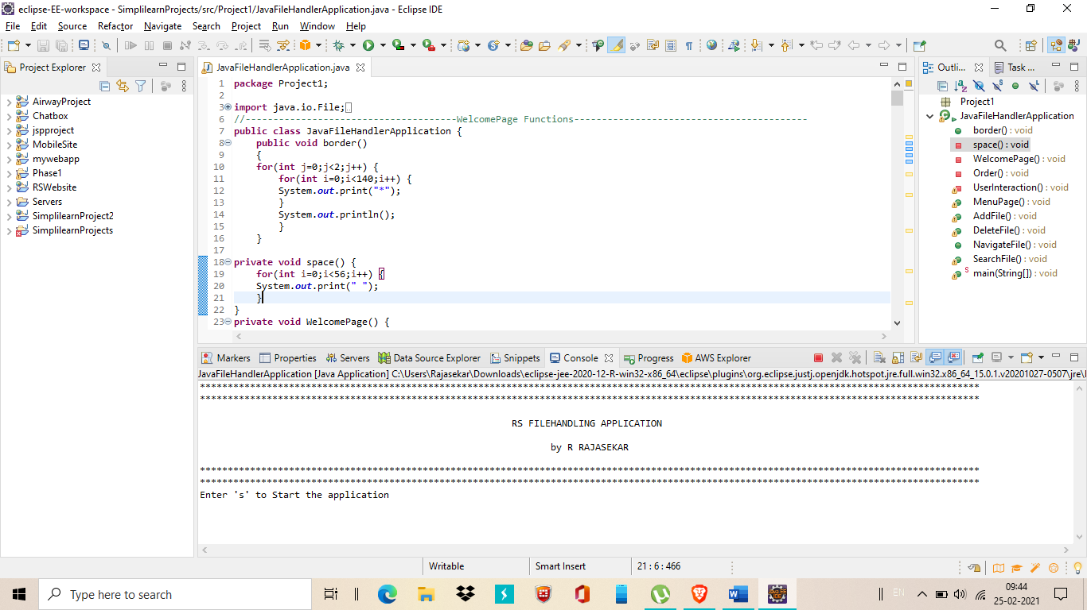

2.Enter ‘s’ to Start the application

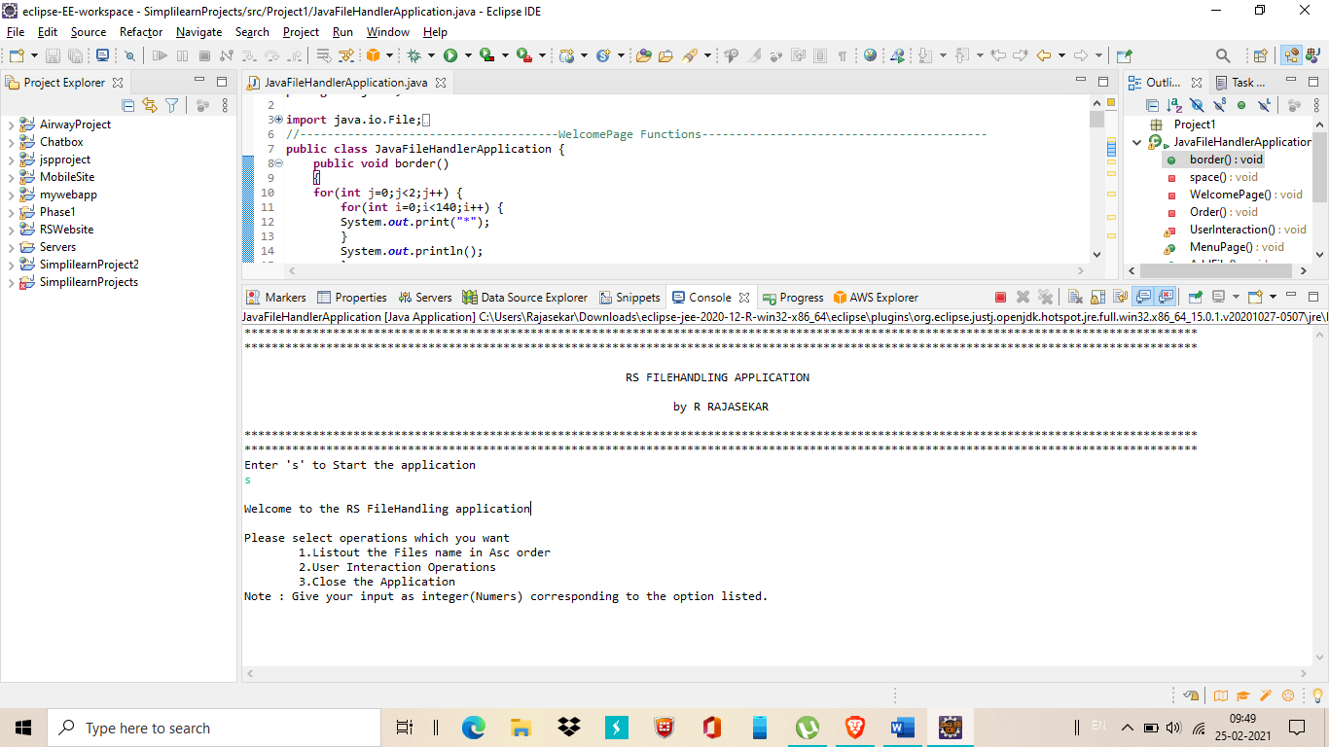

3.It list out operation of list a file name in Ascending order(1), User Interaction operations(2) and close the application. Enter 1 for list all file names in ascending order and return to main page again.

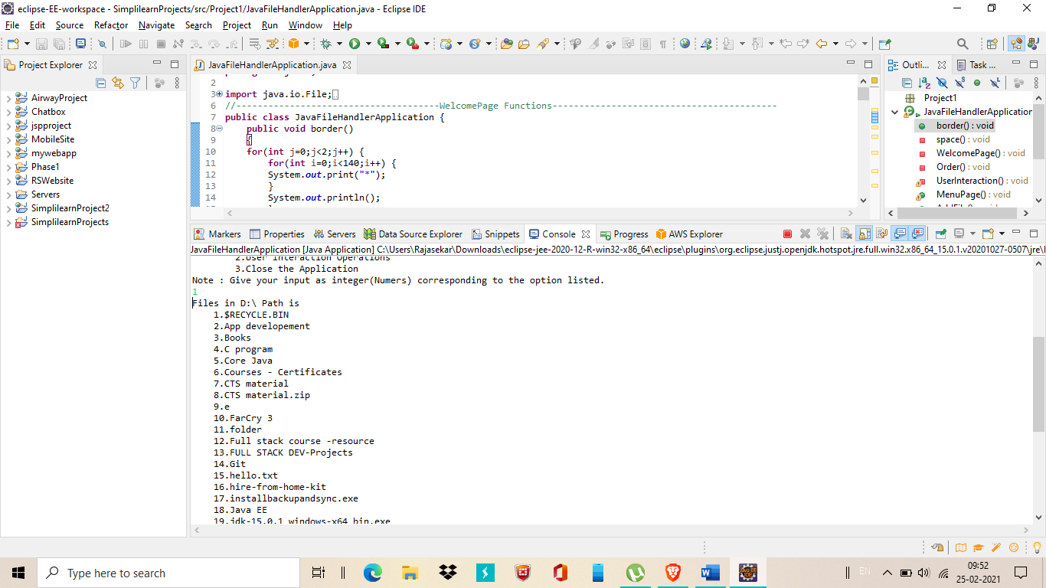

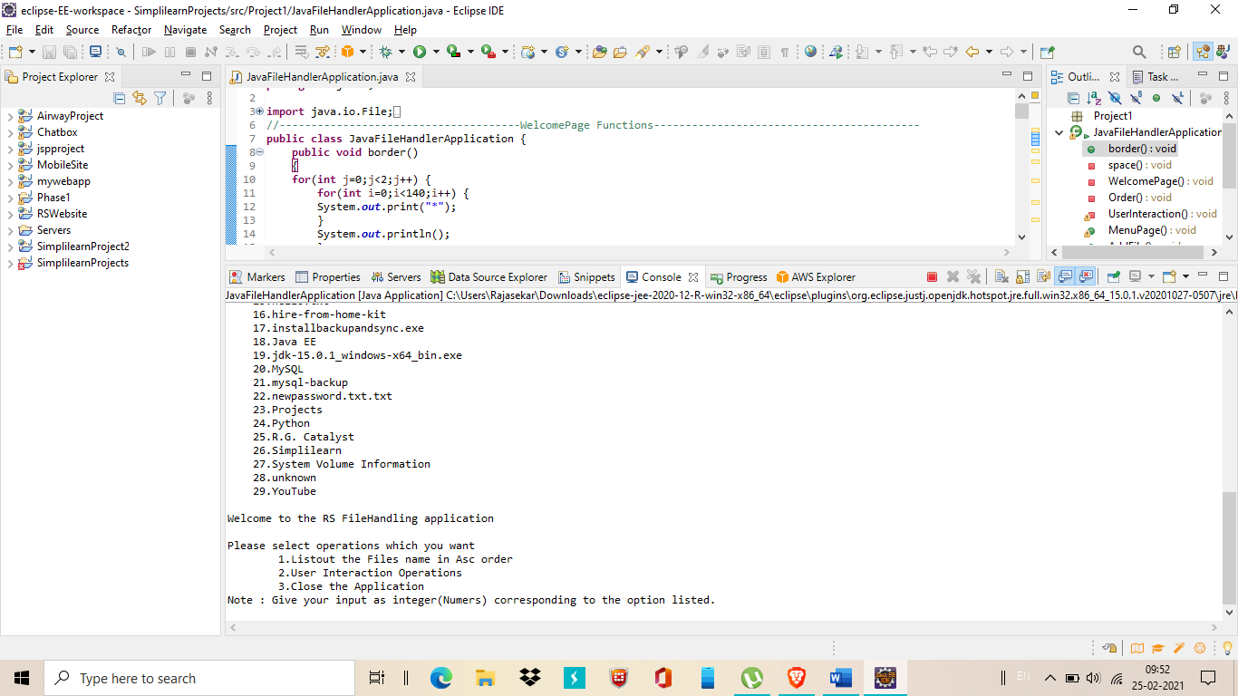

4. Enter 2 for User interaction Operations

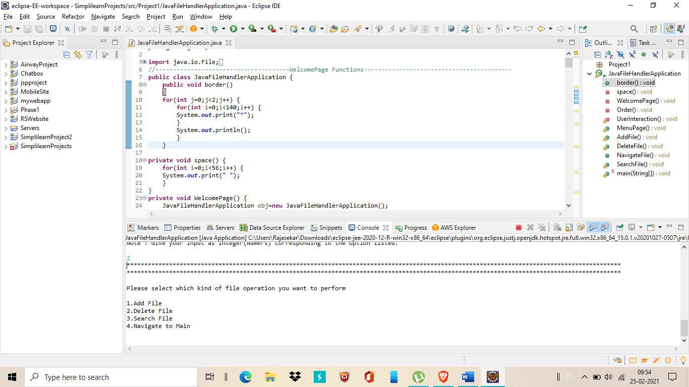

5.Enter 1 for add/create new file.

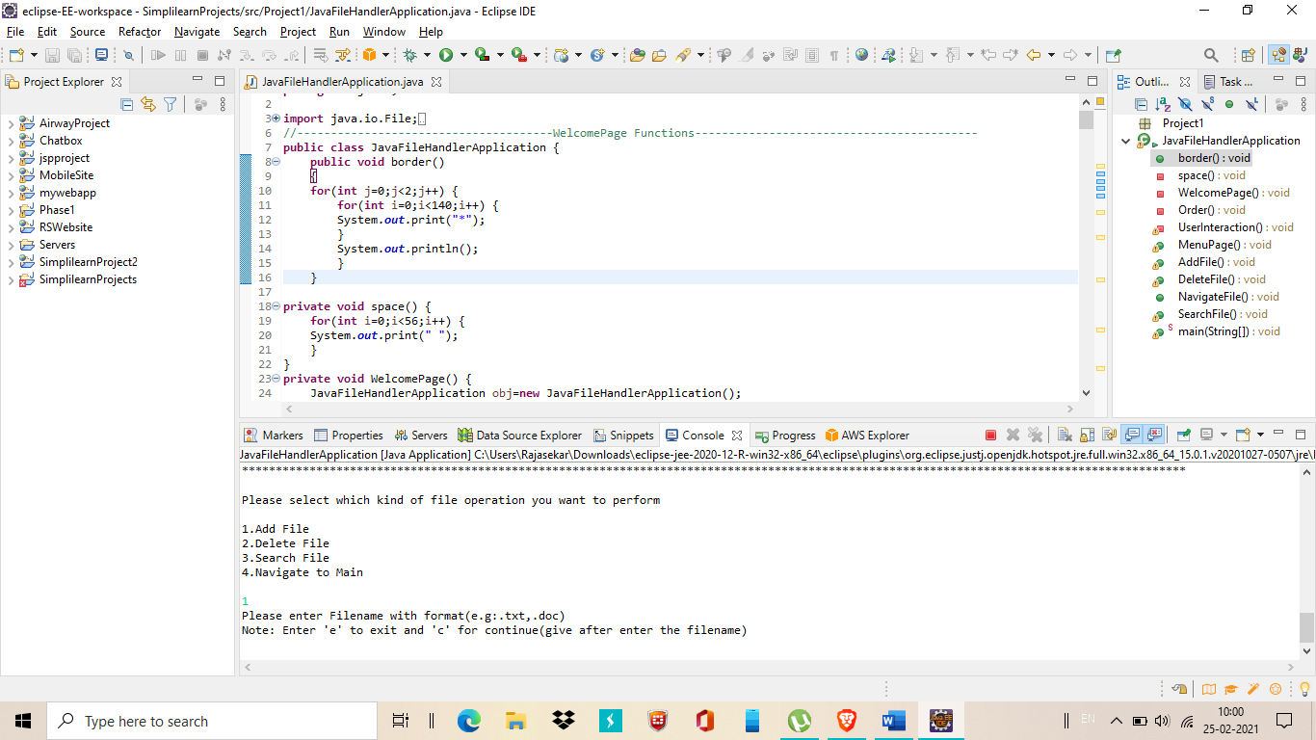

6.Now Enter a file name with format(e.g: note.txt). after enter the file name it check the file is exist or not. If not exist it create new file and return success message.

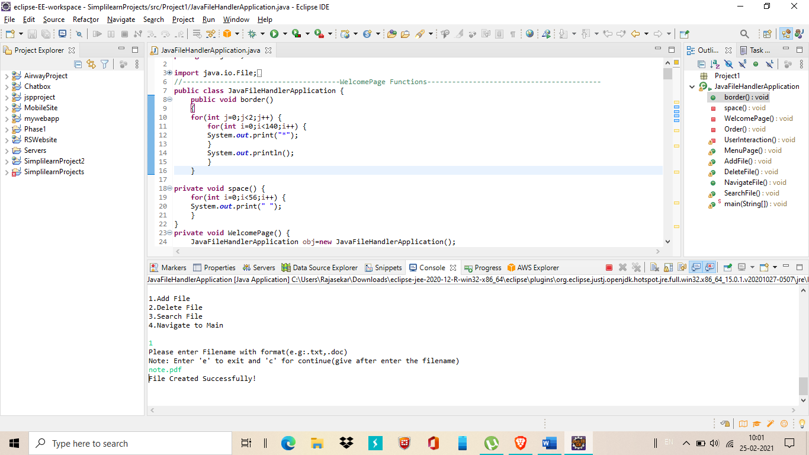

7.After operation done if you want to do the operation again enter ‘c’ or if you want to exit the operation enter ‘e’. If file already exist it return File already exist message.

*Here user enter ’c’ so it continue the process again

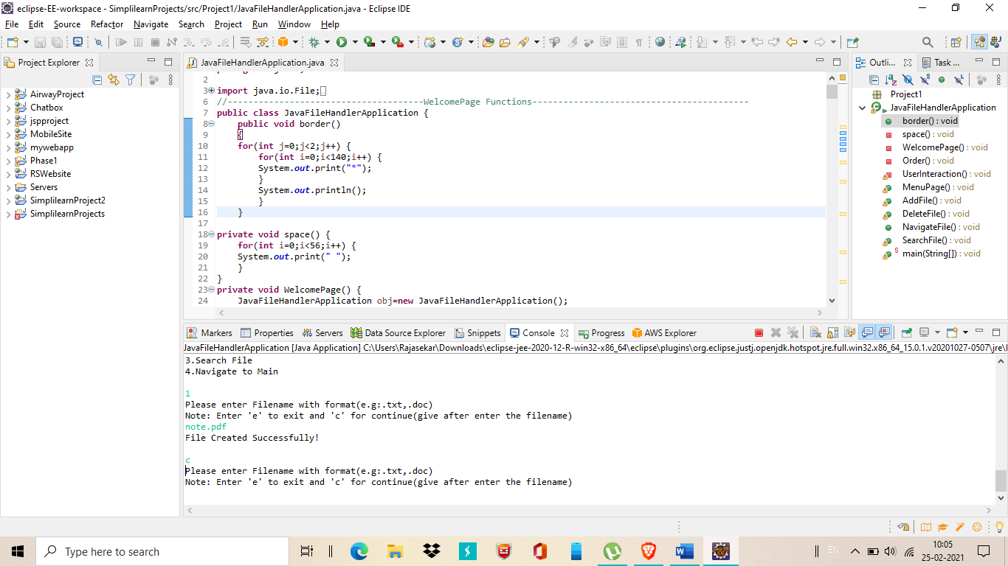

*Here entered file name already exist so it return File already exist message

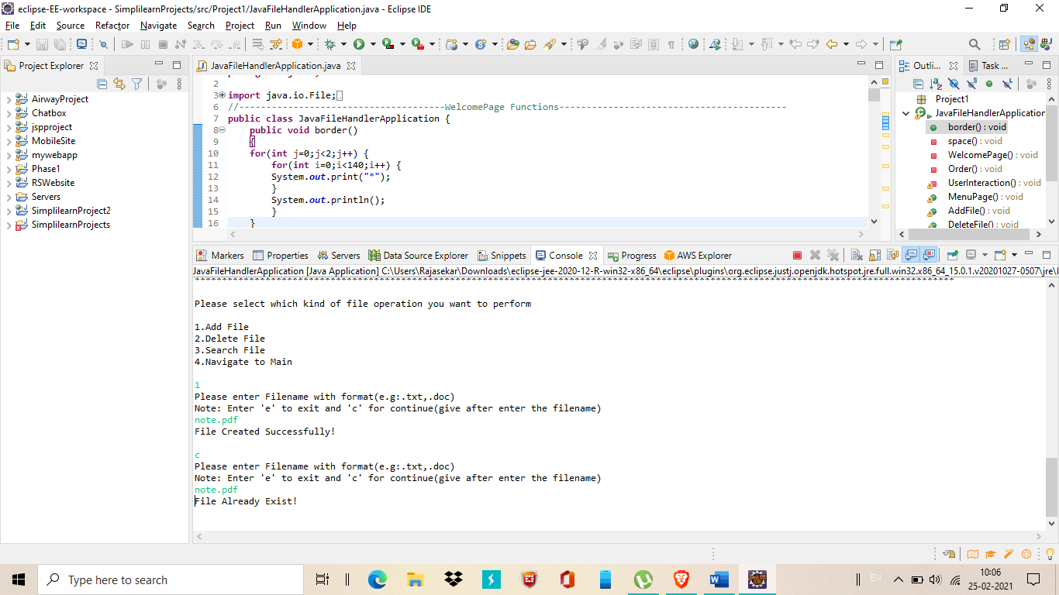

*Now user enter ‘e’ to exit from the operation

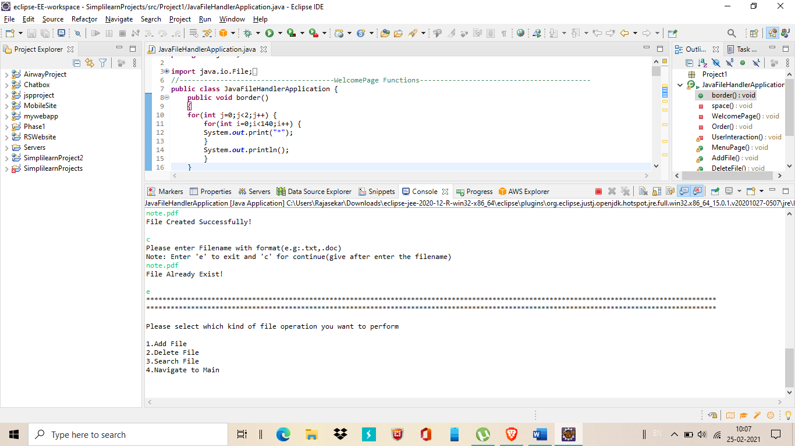

8. Now enter 2 for delete the file from dedicated path

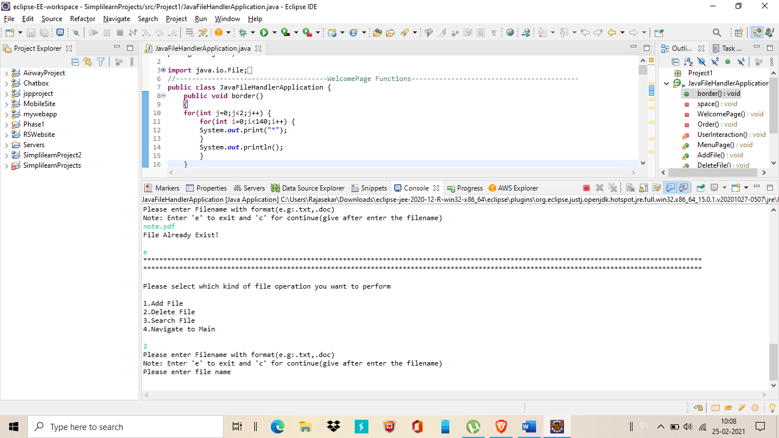enter the file name for perform the delete operation. After enter the file name press enter it return success message if file deleted. If entered file name not exist in the path then it return file not found message.

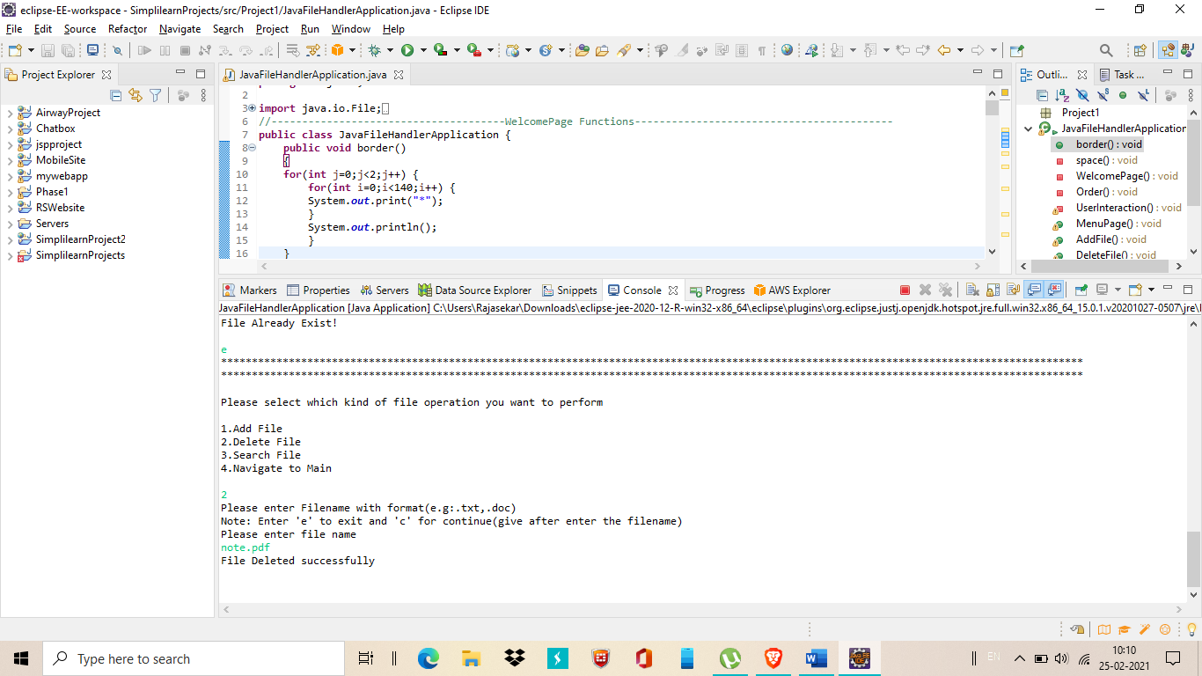

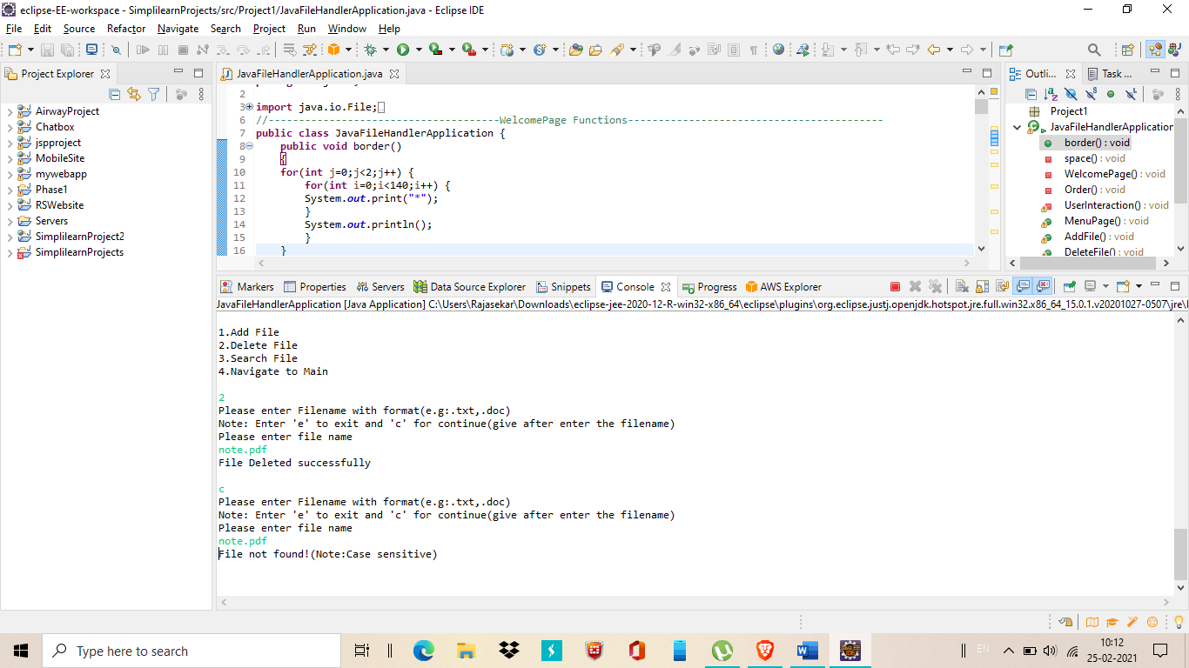

9. Return to User interaction Operations the enter 3 for perform Search file operation. Enter any name. If entered file name founded in dedicated path it return ‘File Founded’ message. Else it return file not found message.(Note: similarly you can perform ‘e’ or ‘c’ function here for exit or continue.)

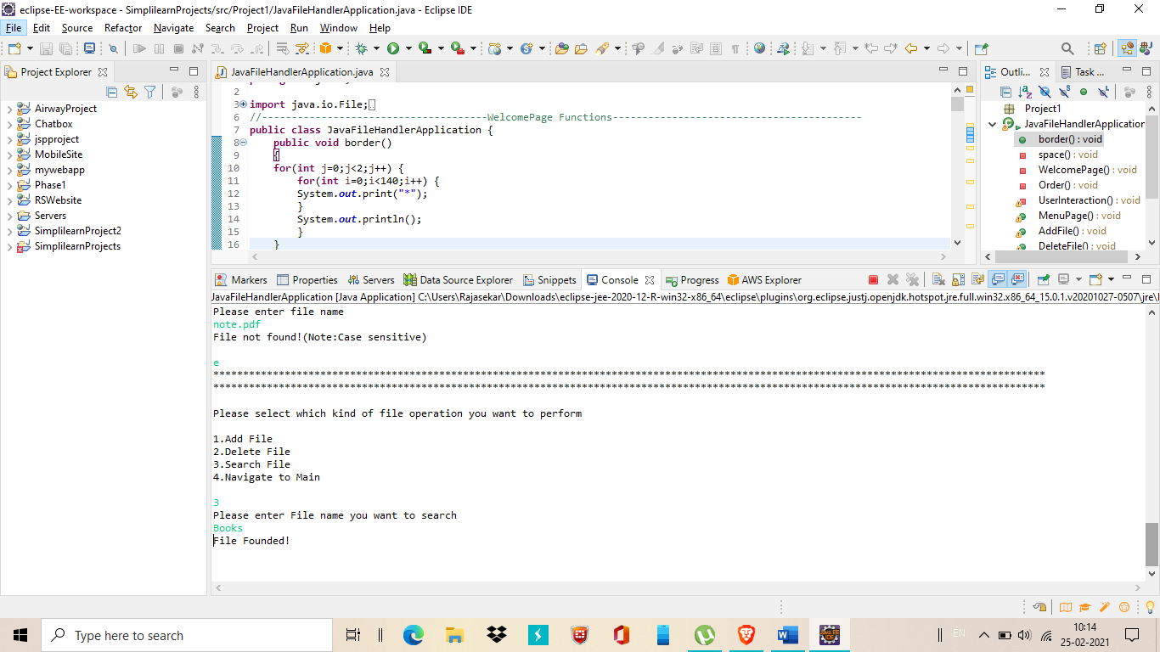

10. Option 4 for Navigate to main menu

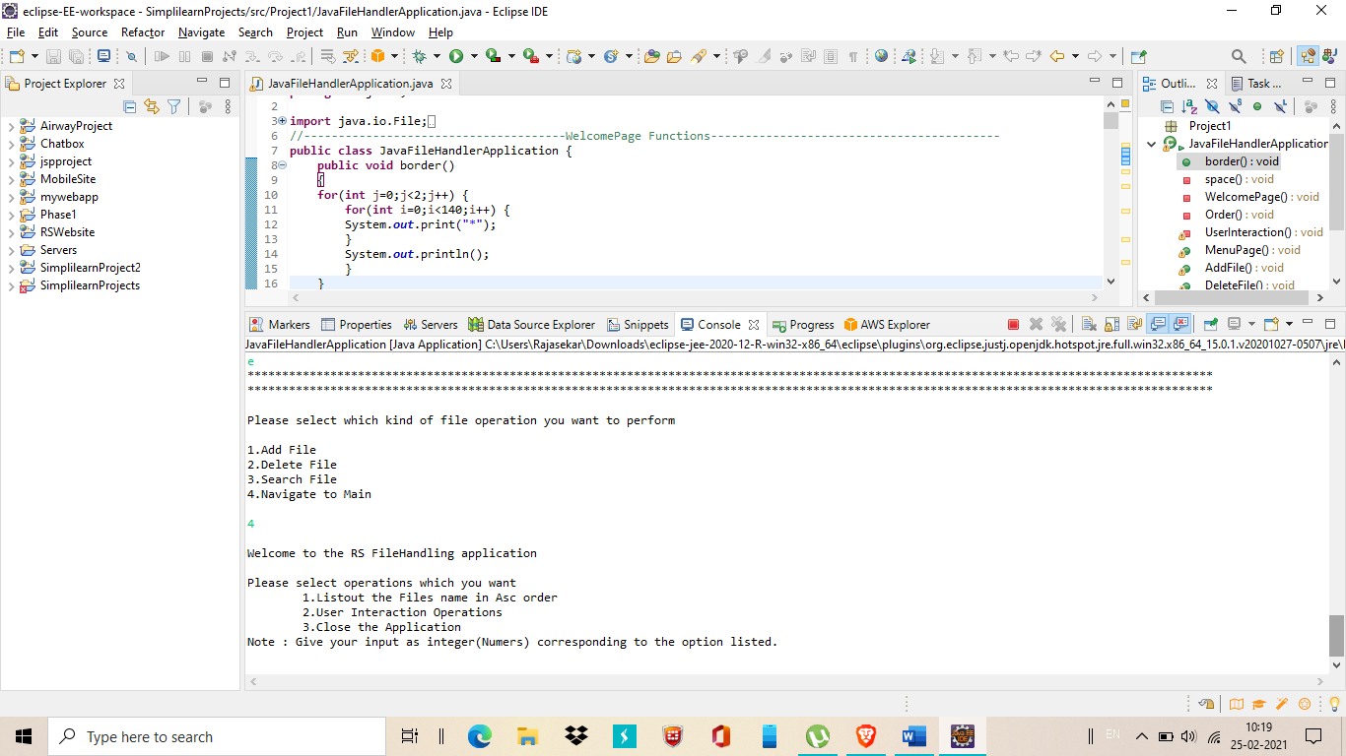

11. In Main page enter 3 for close the application

